**Project Name : Build Movies Management Application:**

**Create an Application with Home Page and Movies Page with below functionality**:

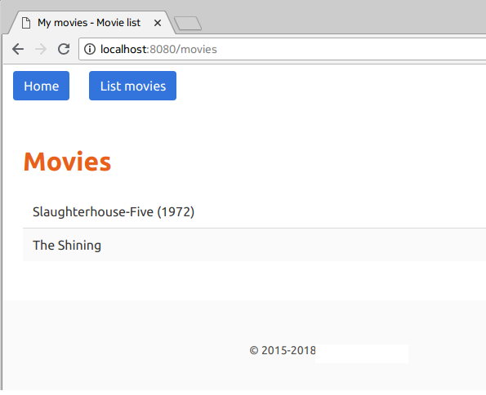

Extended to above display of movies list to displayed using List Movies ,

**Provide functionality for Adding new movies and Deleting existing movies which are not needed to display in given list.**